Name:________________________________________________

- (5 points)What is the mean, median and mode for this set of data?
118 | 145 | 193
119 | 122 | 211
122 | 143 | 225
124 | 145 | 219
124 | 166 | 326

Mean
Median
Mode

- (5 points) Is this data normally distributed?

- (5 points) The purpose of a sample is to infer something about the _______________________.

- (10 points) Calculate the relative frequency by age of vehicle for the following data: (the categories will be the age of the vehicle – you are trying to establish a frequency distribution for how many recalls there are by age of vehicle)
AGE OF VEHICLE | RECALLS
2 | 1
3 | 3
3 | 1
1 | 3
2 | 2
3 | 2
2 | 2
1 | 1
2 | 3
5 | 3
3 | 1
1 | 2
2 | 1
1 | 3
1 | 3
2 | 3
3 | 3
2 | 3
4 | 3
1 | 4
6 | 5
7 | 10
1 | 6

- (10 Points) What is the weighted average revenue per room for this data?
Week | Rooms Rented | Revenue | Complaints
1 | 22 | $ 1,870.00 | 0
2 | 13 | $ 1,590.00 | 2
3 | 10 | $ 1,760.00 | 1
4 | 16 | $ 2,345.00 | 0
5 | 23 | $ 4,563.00 | 2
6 | 13 | $ 1,630.00 | 1
7 | 11 | $ 2,156.00 | 0
8 | 13 | $ 1,756.00 | 0

- (5 points) Using the table in #5 what is the average number of complaints per week?
- (15 points)A survey of the local gas prices produced the following data. What is the range, median, mode and variance for the sample data?
AVE GAS PRICE
2.999
3.129
3.299
4.799
3.299
2.499
3.199
3.219
3.249
3.299
4.279
2.779
3.499
4.259
3.989

- (5 points) What is relative frequency and how does it differ from cumulative relative frequency?

- (10 points) Calculate the Coefficient of Variance for the following data: A sample of gas prices was taken in two cities; the sample set is shown below.
LA | Las Vegas
4.75 | 3.78
3.99 | 3.31
4.26 | 3.46
3.49 | 3.81
3.31 | 3.45
3.64 | 3.69
3.59 | 4.01
3.69 | 5.34
3.59 | 3.32
3.31 | 3.78
3.98 | 4.99
3.66 | 3.88

- (5 points) Which city’s prices have largest variability?

- (20 points)
54 | 14 | 18 | 35 | 13 | 92 | 23 | 22
60 | 15 | 22 | 41 | 14 | 91 | 28 | 12
55 | 38 | 38 | 50 | 18 | 89 | 35 | 13
70 | 23 | 22 | 37 | 37 | 75 | 29 | 7
73 | 27 | 18 | 40 | 44 | 77 | 13 | 11
74 | 23 | 22 | 42 | 16 | 40 | 27 | 21
86 | 28 | 21 | 13 | 11 | 78 | 28 | 28
94 | 19 | 10 | 47 | 16 | 84 | 42 | 33
99 | 26 | 12 | 14 | 12 | 98 | 29 | 31
80 | 14 | 8 | 50 | 5 | 96 | 30 | 29
a. Determine the number of classes for this data
b. Establish the class widths
c. Determine the frequency for each class

- (20 points) The test scores for a sample of the class are shown below. Use this data to answer the questions below.
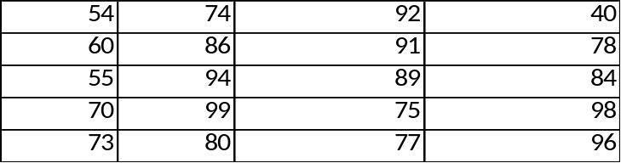

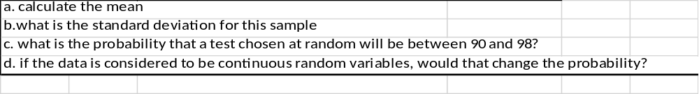

- (10 Points) A company is placing bids on contracts to build a hotel in Las Vegas and an office building in Los Angeles. The probability of winning the bid on the hotel (P(H)) is =.3; The probability of winning the contract to build the office building (P(O)) is .25. The two bids are independent events.
a. What is the probability of the company winning both bids?
b. What is the probability of winning one or the other bid?

- (10 points) Using the following data, compute the probability that a process will take between 27 and 32 minutes to complete:
μ = 30
σ = 3.7
P(27≤ x ≤ 32)

- (10 points) What is the difference between mutually exclusive and collectively exhaustive? Provide an example of each.

- (10 points) what is the probability of getting a sample proportion of .35 given the following data?
  - $π= .39$
  - n = 100

- (10 points)What is the probability of getting a sample mean greater than 40 given the following data?
  - µ = 37
  - $δ=5.2$
  - n=16

- (5 points) Given the contingency table below,
  - Given that the vehicle is a Ford, what is the probability that it is yellow?
  - What is the probability that any randomly selected vehicle is a red Ford?
 | Blue | Red | Yellow
ford | 475 | 150 | 200
chevy | 20 | 30 | 75
VW | 200 | 400 | 100

- (10 points) A sample of 15 sheets of metal from a large normal population has a mean thickness of 35.45 mm. We know from previous quality control testing that the population standard deviation is 3.35 mm. Develop a 95% confidence interval for the true mean for the population.

- (10 Points) A random sample of 20 people has mean = 50 years old and sample standard deviation of 8 years. Form an 80% confidence interval for the mean.

- (10 points) A random sample of 800 people in Lawrence shows that 275 are Republicans. The historical µ is .4. Form a 90% confidence interval for the true proportion of Democrats.

- (5 points) What is the smallest sample size that a company can get by with assuming that the historical proportion ( ∏ ) is .22?

On my honor, I have neither given nor received any unauthorized aid on this exam. Nor
am I aware of anyone giving or receiving any unauthorized aid on this exam.
__________________________________________________

